RESOLUTION NO.__________

RE: CERTIFICATE OF APPROPRIATENESS UNDER THE
PROVISIONS OF THE ACT OF THE PENNSYLVANIA
LEGISLATURE 1961, JUNE 13, P.L. 282 (53
SECTION 8004) AND BETHLEHEM ORDINANCE NO.
3952 AS AMENDED.

WHEREAS, it is proposed to install a generator at 334 13th Avenue.

NOW, THEREFORE, BE IT RESOLVED by the Council of the City of Bethlehem that a Certificate of Appropriateness is hereby granted for the work.

Sponsored by: (s)

(s)

ADOPTED BY COUNCIL THIS DAY OF

(s)
President of Council

ATTEST:

(s)
City Clerk

HISTORIC CONSERVATION COMMISSION

CASE # 603– It is proposed to install a generator at 334 13th Ave
OWNER/APPLICANT: Catholic Housing Corporation of Bethlehem/Holy Family Apartments

The Commission upon motion by Mr. Evans seconded by Mr. Traupman adopted the proposal that City Council issue a Certificate of Appropriateness for the proposed work described herein:
- The proposal to install a generator at 334 13th Ave was represented by Miki Weaver.
- The backup generator will be installed behind the community building as proposed. The location is not highly visible from the street.
- Low landscaping or shrubbery will be installed about it to shield the generator from view.

- The motion to approve the proposal was unanimously approved.

CU: cu
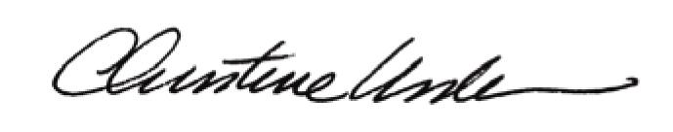

By:

Date of Meeting: November 21, 2016 Title: Historic Officer

